AUTOMATIC BELL SYSTEM FOR SCHOOLS/ COLLEGES

ABSTRACT
The project is designed to operate an electric bell number of times as required in an institution. It overcomes the difficulties of switching the bell ON/OFF manually. This proposed has an inbuilt real time clock (RTC) to keep tracking the time and thus to switch ON/OFF the load accordingly.
The project uses a real time clock (RTC) interfaced to a microcontroller of PIC family. While the set time equals to the real time, then microcontroller gives command to the corresponding relay to turn ON the bell and then another command to switch OFF as per the program. Multiple ON/OFF time entry is the biggest advantage with this project. A matrix keypad helps entering the time. A 7-sement display is interfaced to the microcontroller to display time.
Further the project can be enhanced by interfacing a GSM modem to the existing project so that the complete control of the bell can be done by sending an SMS to the control unit.

BLOCK DIAGRAM
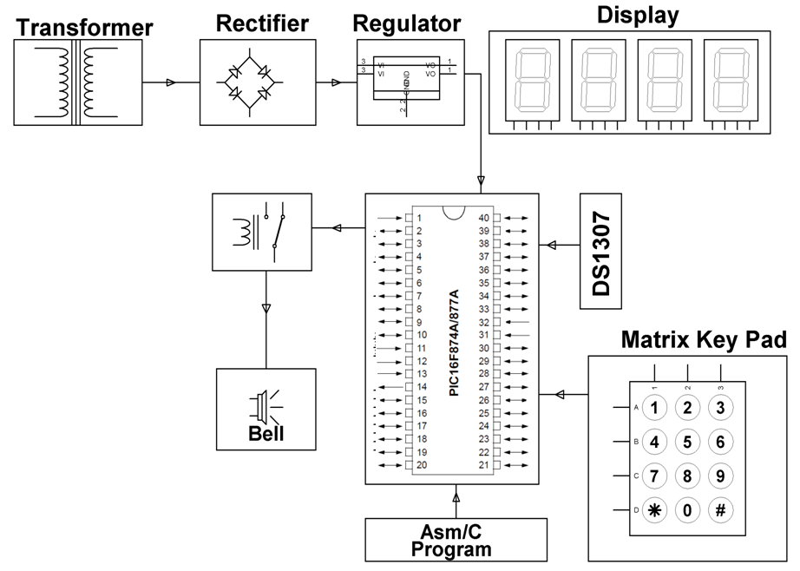
HARDWARE REQUIREMENTS:
PIC series Microcontroller, 7-Segment Display, RTC, Keypad, Relay, Relay Driver, LED, Crystal, Transformer, Diodes, Regulator, Capacitors, Resistors, Bell.
.

SOFTWARE REQUIREMENTS:

HI-TECH PICC Tool suite

Language: Embedded C or Assembly

